### UNIT-III

**3.1 Time-domain Analysis of Control Systems**

In time-domain analysis the response of a dynamic system to an input is expressed as a function of time. It is possible to compute the time response of a system if the nature of input and the mathematical model of the system are known.

Usually, the input signals to control systems are not known fully ahead of time. In a radar tracking system, the position and the speed of the target to be tracked may vary in a random fashion. It is therefore difficult to express the actual input signals mathematically by simple equations. The characteristics of actual input signals are a sudden shock, a sudden change, a constant velocity, and constant acceleration. The dynamic behavior of a system is therefore judged and compared under application of standard test signals – an impulse, a step, a constant velocity, and constant acceleration. Another standard signal of great importance is a sinusoidal signal.

The time response of any system has two components: transient response and the steady-state response. Transient response is dependent upon the system poles only and not on the type of input. It is therefore sufficient to analyze the transient response using a step input. The steady-state response depends on system dynamics and the input quantity. It is then examined using different test signals by final value theorem.

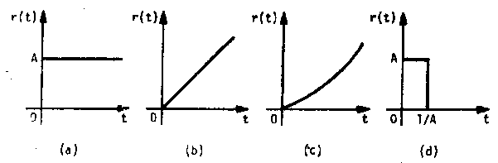**Standard test signals**

1. Step signal: 
2. Ramp signal: 
3. Parabolic signal:
4. Impulse signal: 

**Time-response of first-order systems**

Let us consider the armature-controlled dc motor driving a load, such as a video tape. The objective is to drive the tape at constant speed. Note that it is an open-loop system.

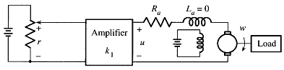

; If , 

; 

****is the steady-statefinal speed. If the desired speed is , choosing the motor will eventually reach the desired speed.

We are interested not only in final speed, but also in the speed of response. Here, is the time constant of motor which is responsible for the speed of response.

The time response is plotted in the Figure in next page. A plot of is shown, from where it is seen that, for the value of is less than 1% of its original value. Therefore, the speed of the motor will reach and stay within 1% of its final speed at 5 time constants.

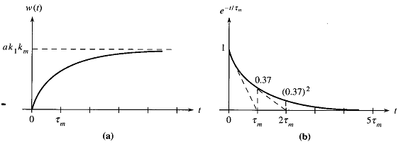

Figure: Time responses

Let us now consider the closed-loop system shown below.

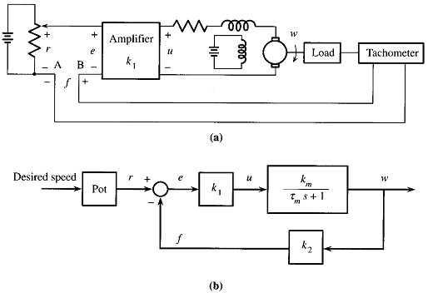

Here, 

where, and .

If , the response would be, .

If a is properly chosen, the tape can reach a desired speed. It will reach the desired speed in 5seconds. Here, . Thus, we can control the speed of response in feedback system.

Although the time-constant is reduced by a factor , in the feedback system, the motor gain constant is also reduced by the same factor. In order to compensate for this loss of gain, the applied reference voltage must be increased by the same factor.

**Ramp response of first-order system**

Let,  for simplicity. Then, . Also, let, .

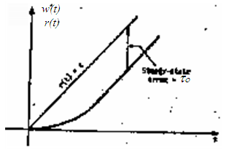Then, ;



The error signal is, 

Or, 



Thus, the first-order system will track the unit ramp input with a steady-state error , which is equal to the time-constant of the system.

**Time-response of second-order systems**

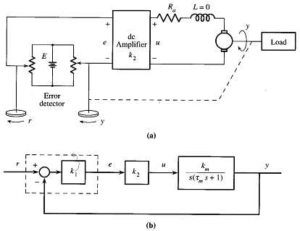

Consider the antenna position control system. Its transfer function from *r* to *y* is,



where, we define, and . The constant is called the *damping ratio* and is called the *natural frequency*. The system above is in fact a standard second order system.

The transfer function has two poles and no zero. Its poles are,

.

Here, is called the *damping factor*, is called *damped or actual frequency*.

The location of poles for different are plotted in Figure below. For, the two poles  are purely imaginary. If , the two poles are complex conjugate. All possible cases are described in a table shown below.

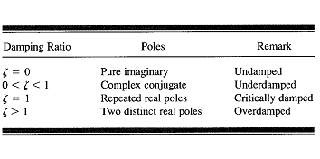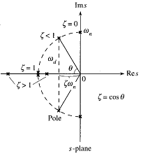

**Unit step response of second-order systems**

**Natural frequency, *ωn***

The natural frequency of a second order system is the frequency of oscillation of the system without damping.

**Damping ratio, *ζ***

The damping ratio is defined as the ratio of the damping factor,  to the natural frequency.

Suppose, .

Comparing with standard equation, and .

Suppose, ; 

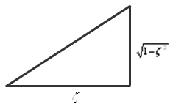Or, 

Performing inverse Laplace transform,



or, 

or, ,where, and

or,  ……………………………………………………….(01)

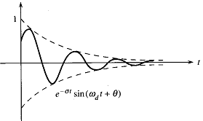The plot of is shown in Figure.

The steady-state response is,



Thus, the system has zero steady-state error.

The pole of dictates the response,

.

The response for different is shown in Figure below.

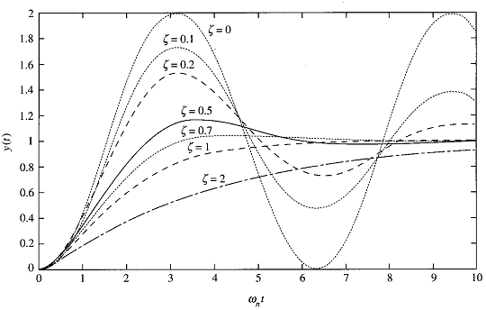

**3.2 Time response specifications**

Control systems are generally designed with damping less than one, i.e., oscillatory step response. Higher order control systems usually have a pair of complex conjugate poles with damping less than unity that dominate over the other poles. Therefore the time response of second- and higher-order control systems to a step input is generally of damped oscillatory nature as shown in Figure next (next page).

In specifying the transient-response characteristics of a control system to a unit step input, we usually specify the following:

1. Delay time, 
2. Rise time, 
3. Peak time, 
4. Peak overshoot, 
5. Settling time, 
6. Steady-state error, 

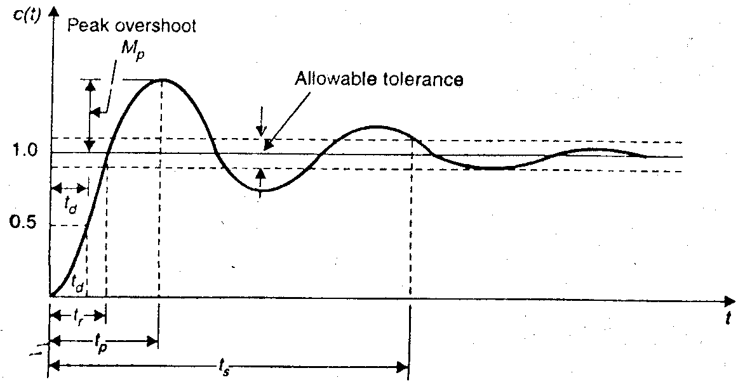

1. ***Delay time, :*** It is the time required for the response to reach 50% of the final value in first attempt.

2. ***Rise time, :*** It is the time required for the response to rise from 0 to 100% of the final value for the underdamped system.

3. ***Peak time, :*** It is the time required for the response to reach the peak of time response or the peak overshoot.

4. ***Settling time, :*** It is the time required for the response to reach and stay within a specified tolerance band ( 2% or 5%) of its final value.

5. ***Peak overshoot, :*** It is the normalized difference between the time response peak and the steady output and is defined as,



6. ***Steady-state error, :*** It indicates the error between the actual output and desired output as ‘t’ tends to infinity.

.

Let us now obtain the expressions for the rise time, peak time, peak overshoot, and settling time for the second order system.

1. ***Rise time, :*** Put  at ,,;.

2. ***Peak time, :*** Put and solve for ; .

, 

Peak overshoot occurs at *k = 1*. .

3. ***Settling time, :*** For 2% tolerance band, , .

4. ***Steady-state error, :*** It is found previously that steady-state error for step input is zero.

Let us now consider ramp input, .

Then, 

.

Therefore, the steady-state error due to ramp input is.

**Steady-state error and error constants**

The steady-state performance of a stable control system is generally judged by its steady-state error to step, ramp and parabolic inputs. For a unity feedback system,

,.

It is seen that steady-state error depends upon the input and the forward transfer function. The steady-state errors for different inputs are derived as follows:

1. For unit-step input: 

; is called position error constant.

2. For unit-ramp input: 

; is called velocity error constant.

3. For unit-parabolic input: 

;  is called acceleration error const.

**3.3 Types of Feedback Control System**

The open-loop transfer function of a system can be written as,



If n = 0, the system is called type-0 system, if n = 1, the system is called type-1 system, if n = 2, the system is called type-2 system, etc. Steady-state errors for various inputs and system types are tabulated below.

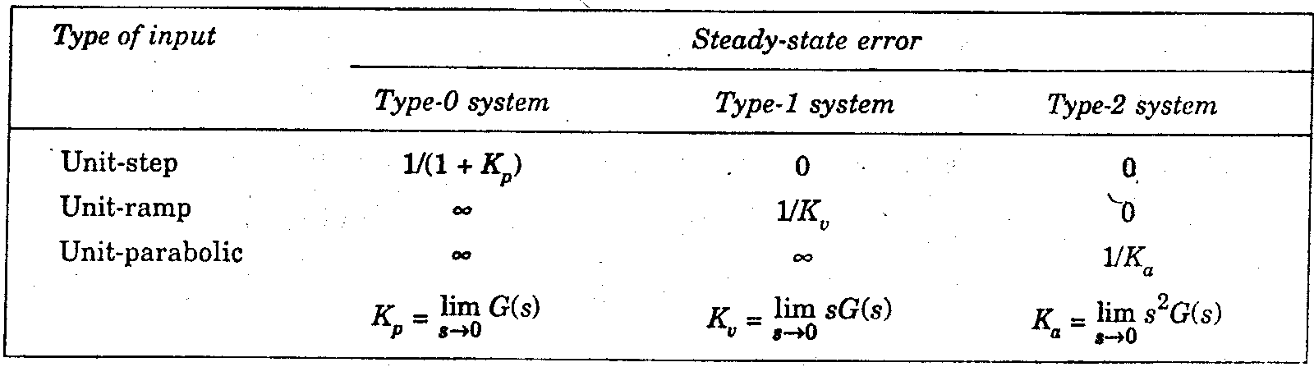

The error constants for non-unity feedback systems may be obtained by replacing G(s) by G(s)H(s). Systems of type higher than 2 are not employed due to two reasons:

1. The system is difficult to stabilize.
2. The dynamic errors for such systems tend to be larger than those

types-0, -1 and -2.

**Effect of Adding a Zero to a System**

Let a zero at s = -z be added to a second order system. Then we have,

.

The multiplication term is adjusted to make the steady-state gain of the system unity. This gives *css = 1* when the input is unit step. Let *cz(t)* be the response of the system given by the above equation and *c(t)* is the response without adding the pole. Manipulation of the above equation gives,



The effect of added derivative term is to produce a pronounced early peak to the system response which will be clear from the figure in the next page. Closer the zero to origin, the more pronounce the peaking phenomenon. Due to this fact, *the zeros on the real axis near the origin are generally avoided in design*. However, in a sluggish system the artful introduction of a zero at the proper position can improve the transient response. We can see from equation (03) that as z increases, i.e., the zero moves further into the left half of the s-plane, its effect becomes less pronounced.

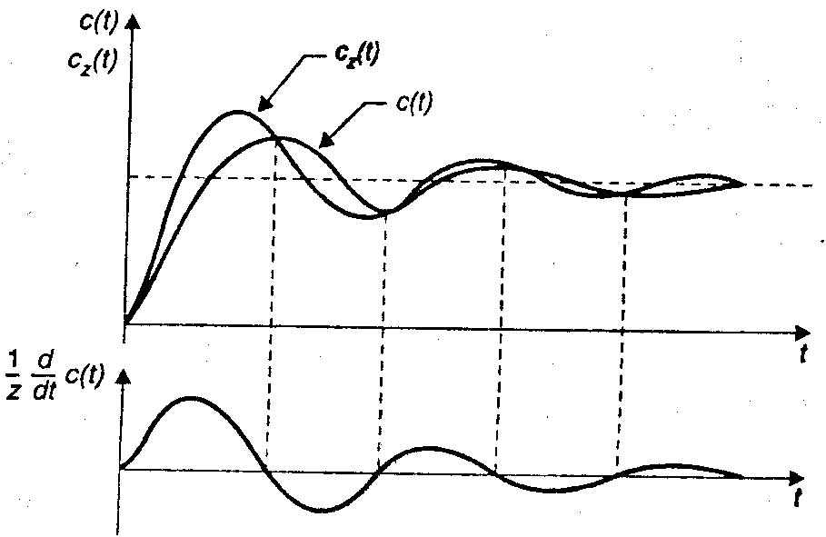

**Design Specifications of Second-order Systems**

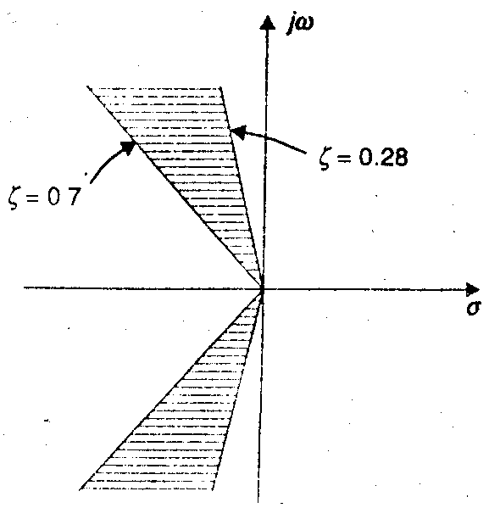 A control system is generally required to meet three time response specifications: steady-state accuracy, damping factor ζ (or peak overshoot, *Mp*) and settling time *ts*. Steady-state accuracy requirement is met by suitable choice of *Kp, Kv, or Ka* depending on the type of the system. For most control systems ζ in the range of 0.7 – 0.28 (or peak overshoot of 5 – 40%) is considered acceptable. For this range of ζ, the closed-loop pole locations are restricted to the shaded region of the s-plane as shown in Figure.

For the antenna position control system,;;;. Here, is only the adjustable parameter. If we increase, will increase and thus settling time will decrease. At the same time, will decrease, this indicates the increase in peak overshoot. Thus by merely increasing gain, we cannot improve both transient and steady-state error specifications. We need to add additional components to the system. These are called compensators. It will allow improvement of both transient and steady-state specifications.

**3.4 Routh Hurwitz Stability Criterion**

After reading the theory of [network synthesis](https://www.electrical4u.com/network-synthesis-hurwitz-polynomial-positive-real-functions/), we can easily say that any pole of the system lies on the right hand side of the origin of the s plane, it makes the system unstable. On the basis of this condition A. Hurwitz and E.J.Routh started investigating the necessary and sufficient conditions of stability of a system. We will discuss two criteria for stability of the system. A first criterion is given by A. Hurwitz and this criterion is also known as **Hurwitz Criterion for stability** or **Routh Hurwitz Stability Criterion**.

## Hurwitz Criterion

With the help of characteristic equation, we will make a number of Hurwitz determinants in order to find out the stability of the system. We define characteristic equation of the system as

Now there are n determinants for nth order characteristic equation.

Let us see how we can write determinants from the coefficients of the characteristic equation. The step by step procedure for kth order characteristic equation is written below:  
**Determinant one :** The value of this determinant is given by |a1| where a1 is the coefficient of

sn-1 in the characteristic equation.

**Determinant two :** The value of this determinant is given byHere number of elements in each row is equal to determinant number and we have determinant number here is two. The first row consists of first two odd coefficients and second row consists of first two even coefficients.  
**Determinant three** : The value of this determinant is given by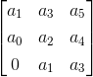Here number of elements in each row is equal to determinant number and we have determinant number here is three. The first row consists of first three odd coefficients, second row consists of first three even coefficients and third row consists of first element as zero and rest of two elements as first two odd coefficients.  
**Determinant four:** The value of this determinant is given by,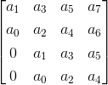Here number of elements in each row is equal to determinant number and we have determinant number here is four. The first row consists of first three four coefficients, second row consists of first four even coefficients, third row consists of first element as zero and rest of three elements as first three odd coefficients the fourth row consists of first element as zero and rest of three elements as first three even coefficients.  
By following the same procedure we can generalize the determinant formation. The general form of determinant is given below: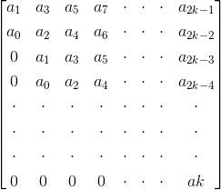Now in order to check the stability of the above system, calculate the value of each determinant. The system will be stable if and only if the value of each determinant is greater than zero, i.e. the value of each determinant should be positive. In all the other cases the system will not be stable.

## Routh Stability Criterion

This criterion is also known as modified Hurwitz Criterion of stability of the system. We will study this criterion in two parts. Part one will cover necessary condition for stability of the system and part two will cover the sufficient condition for the stability of the system. Let us again consider the characteristic equation of the system as**1) Part one (necessary condition for stability of the system):** In this we have two conditions which are written below:

1. All the coefficients of the characteristic equation should be positive and real.
2. All the coefficients of the characteristic equation should be non zero.

**2) Part two (sufficient condition for stability of the system):** Let us first construct routh array. In order to construct the routh array follow these steps:

* The first row will consist of all the even terms of the characteristic equation. Arrange them from first (even term) to last (even term). The first row is written below: a0 a2 a4a6............
* The second row will consist of all the odd terms of the characteristic equation. Arrange them from first (odd term) to last (odd term). The first row is written below: a1 a3 a5a7...........
* The elements of third row can be calculated as:  
  **(1) First element :** Multiply a0 with the diagonally opposite element of next column (i.e. a3) then subtract this from the product of a1 and a2 (where a2 is diagonally opposite element of next column) and then finally divide the result so obtain with a1. Mathematically we write as first element



**(2) Second element :** Multiply a0 with the diagonally opposite element of next to next column (i.e. a5) then subtract this from the product of a1 and a4 (where, a4 is diagonally opposite element of next to next column) and then finally divide the result so obtain with a1. Mathematically we write as second elementSimilarly, we can calculate all the elements of the third row.  
(d) The elements of fourth row can be calculated by using the following procedure:  
**(1) First element :** Multiply b1 with the diagonally opposite element of next column (i.e. a3) then subtract this from the product of a1 and b2 (where, b2 is diagonally opposite element of next column) and then finally divide the result so obtain with b1. Mathematically we write as first element

**(2) Second element :** Multiply b1 with the diagonally opposite element of next to next column (i.e. a5) then subtract this from the product of a1 and b3 (where, b3 is diagonally opposite element of next to next column) and then finally divide the result so obtain with a1. Mathematically we write as second elementSimilarly, we can calculate all the elements of the fourth row.  
Similarly, we can calculate all the elements of all the rows.  
Stability criteria if all the elements of the first column are positive then the system will be stable. However if anyone of them is negative the system will be unstable.  
Now there are some special cases related to Routh Stability Criteria which are discussed below:  
**(1)Caseone:**  
If the first term in any row of the array is zero while the rest of the row has at least one non zero term.   
In this case we will assume a very small value (ε) which is tending to zero in place of zero. By replacing zero with (ε) we will calculate all the elements of the Routh array. After calculating all the elements we will apply the limit at each element containing (ε). On solving the limit at every element if we will get positive limiting value then we will say the given system is stable otherwise in all the other condition we will say the given system is not stable.   
**(2)Casesecond:**  
When all the elements of any row of the Routh array are zero. In this case we can say the system has the symptoms of marginal stability. Let us first understand the physical meaning of having all the elements zero of any row. The physical meaning is that there are symmetrically located roots of the characteristic equation in the s plane. Now in order to find out the stability in this case we will first find out auxiliary equation. Auxiliary equation can be formed by using the elements of the row just above the row of zeros in the Routh array. After finding the auxiliary equation we will differentiate the auxiliary equation to obtain elements of the zero row. If there is no sign change in the new routh array formed by using auxiliary equation, then in this we say the given system is limited stable. While in all the other cases we will say the given system is unstable.

**3.5 Root Locus Technique in Control System | Root Locus Plot**

The **root locus technique in control system** was first introduced in the year 1948 by Evans. Any physical system is represented by a transfer function in the form ofhttps://www.electrical4u.com/equations/controlsystem/rlt-17-06-14-01.gif

We can find poles and zeros from G(s). The location of poles and zeros are crucial keeping view stability, relative stability, transient response and error analysis. When the system put to service stray [inductance](https://www.electrical4u.com/what-is-inductor-and-inductance-theory-of-inductor/) and [capacitance](https://www.electrical4u.com/what-is-capacitor-and-what-is-dielectric/) get into the system, thus changes the location of poles and zeros. In **root locus technique in control system** we will evaluate the position of the roots, their locus of movement and associated information. These information will be used to comment upon the system performance.

Now before I introduce what is a root locus technique, it is very essential here to discuss a few of the advantages of this technique over other stability criteria. Some of the advantages of root locus technique are written below.

### Advantages of Root Locus Technique

1. Root locus technique in control system is easy to implement as compared to other methods.
2. With the help of root locus we can easily predict the performance of the whole system.
3. Root locus provides the better way to indicate the parameters.

Now there are various terms related to root locus technique that we will use frequently in this article.

1. **Characteristic Equation Related to Root Locus Technique :** 1 + G(s)H(s) = 0 is known as characteristic equation. Now on differentiating the characteristic equation and on equating dk/ds equals to zero, we can get break away points.
2. **Break away Points :** Suppose two root loci which start from pole and moves in opposite direction collide with each other such that after collision they start moving in different directions in the symmetrical way. Or the break away points at which multiple roots of the characteristic equation 1 + G(s)H(s)= 0 occur. The value of K is maximum at the points where the branches of root loci break away. Break away points may be real, imaginary or complex.
3. **Break in Point :** Condition of break in to be there on the plot is written below : Root locus must be present between two adjacent zeros on the real axis.
4. **Centre of Gravity :** It is also known centroid and is defined as the point on the plot from where all the asymptotes start. Mathematically, it is calculated by the difference of summation of poles and zeros in the transfer function when divided by the difference of total number of poles and total number of zeros. Centre of gravity is always real and it is denoted by σA

.https://www.electrical4u.com/equations/controlsystem/rlt-17-06-14-07.gifWhere, N is number of poles and M is number of zeros.

1. **Asymptotes of Root Loci :** Asymptote originates from the center of gravity or centroid and goes to infinity at definite some angle. Asymptotes provide direction to the root locus when they depart break away points.
2. **Angle of Asymptotes :** Asymptotes makes some angle with the real axis and this angle can be calculated from the given formula,

https://www.electrical4u.com/equations/controlsystem/rlt-17-06-14-02.gif

Where, p = 0, 1, 2 ....... (N-M-1)  
N is the total number of poles  
M is the total number of zeros.

1. **Angle of Arrival or Departure :** We calculate angle of departure when there exists complex poles in the system. Angle of departure can be calculated as 180-{(sum of angles to a complex pole from the other poles)-(sum of angle to a complex pole from the zeros)}.
2. **Intersection of Root Locus with the Imaginary Axis :** In order to find out the point of intersection root locus with imaginary axis, we have to use Routh Hurwitz criterion. First, we find the auxiliary equation then the corresponding value of K will give the value of the point of intersection.
3. **Gain Margin :** We define gain margin as a by which the design value of the gain factor can be multiplied before the system becomes unstable. Mathematically it is given by the formulahttps://www.electrical4u.com/equations/controlsystem/rlt-17-06-14-03.gif
4. **Phase Margin :** Phase margin can be calculated from the given formula:https://www.electrical4u.com/equations/controlsystem/rlt-17-06-14-04.gif
5. **Symmetry of Root Locus :** Root locus is symmetric about the x axis or the real axis.

How to determine the value of K at any point on the root loci? Now there are two ways of determining the value of K, each way is described below.

1. **Magnitude Criteria :** At any points on the root locus we can apply magnitude criteria as,https://www.electrical4u.com/equations/controlsystem/rlt-17-06-14-05.gifUsing this formula we can calculate the value of K at any desired point.
2. **Using Root Locus Plot :** The value of K at any s on the root locus is given byhttps://www.electrical4u.com/equations/controlsystem/rlt-17-06-14-06.gif

## 3.6 Root Locus Plot

This is also known as root locus technique in control system and is used for determining the stability of the given system. Now in order to determine the stability of the system using the root locus technique we find the range of values of K for which the complete performance of the system will be satisfactory and the operation is stable.  
Now there are some results that one should remember in order to plot the root locus. These results are written below:

1. **Region where root locus exists :** After plotting all the poles and zeros on the plane, we can easily find out the region of existence of the root locus by using one simple rule which is written below,

Only that segment will be considered in making root locus if the total number of poles and zeros at the right hand side of the segment is odd.

1. **How to calculate the number of separate root loci ? :** A number of separate root loci are equal to the total number of roots if number of roots are greater than the number of poles otherwise number of separate root loci is equal to the total number of poles if number of roots are greater than the number of zeros.

### Procedure to Plot Root Locus

Keeping all these points in mind we are able to draw the **root locus plot** for any kind of system. Now let us discuss the procedure of making a root locus.

1. Find out all the roots and poles from the open loop transfer function and then plot them on the complex plane.
2. All the root loci starts from the poles where k = 0 and terminates at the zeros where K tends to infinity. The number of branches terminating at infinity equals to the difference between the number of poles & number of zeros of G(s)H(s).
3. Find the region of existence of the root loci from the method described above after finding the values of M and N.
4. Calculate break away points and break in points if any.
5. Plot the asymptotes and centroid point on the complex plane for the root loci by calculating the slope of the asymptotes.
6. Now calculate angle of departure and the intersection of root loci with imaginary axis.
7. Now determine the value of K by using any one method that I have described above.

By following above procedure you can easily draw the **root locus plot** for any open loop transfer function.

1. Calculate the gain margin.
2. Calculate the phase margin.
3. You can easily comment on the stability of the system by using Routh array.

**Types of Controllers | Proportional Integral and Derivative Controllers**

Before I introduce you about various controllers in detail, it is very essential to know the uses of controllers in the theory of control systems. The important uses of the **controllers**are written below:

1. Controllers improve steady state accuracy by decreasing the steady state errors.
2. As the steady state accuracy improves, the stability also improves.
3. They also help in reducing the offsets produced in the system.
4. Maximum overshoot of the system can be controlled using these controllers.
5. They also help in reducing the noise signals produced in the system.
6. Slow response of the over damped system can be made faster with the help of these controllers.

Now what are controllers? A controller is one which compares controlled values with the desired values and has a function to correct the deviation produced.

## 3.7 Types of Controllers

Let us classify the controllers. There are mainly two **types of controllers** and they are written below:   
**Continuous Controllers:** The main feature of continuous controllers is that the controlled variable (also known as the manipulated variable) can have any value within the range of controller’s output. Now in the continuous [controller’s theory](https://www.electrical4u.com/on-off-control-theory-controller/), there are three basic modes on which the whole control action takes place and these modes are written below. We will use the combination of these modes in order to have a desired and accurate output.

1. **Proportional controllers**.
2. **Integral controllers**.
3. **Derivative controllers**.

Combinations of these three controllers are written below:

1. Proportional and integral controllers.
2. Proportional and derivative controllers.

Now we will discuss each of these modes in detail.

### Proportional Controllers

We cannot use **types of controllers** at anywhere, with each type controller, there are certain conditions that must be fulfilled. With **proportional controllers** there are two conditions and these are written below:

1. Deviation should not be large, it means there should be less deviation between the input and output.
2. Deviation should not be sudden.

Now we are in a condition to discuss proportional controllers, as the name suggests in a proportional controller the output (also called the actuating signal) is directly proportional to the error signal. Now let us analyze proportional controller mathematically. As we know in proportional controller output is directly proportional to error signal, writing this mathematically we have,

https://www.electrical4u.com/equations/controlsystem/con-12-06-14-01.gifRemoving the sign of proportionality we have,https://www.electrical4u.com/equations/controlsystem/con-12-06-14-02.gifWhere, Kp is proportional constant also known as controller gain.  
It is recommended that Kp should be kept greater than unity. If the value of Kp is greater than unity, then it will amplify the error signal and thus the amplified error signal can be detected easily.

#### Advantages of Proportional Controller

Now let us discuss some advantages of proportional controller.

1. Proportional controller helps in reducing the steady state error, thus makes the system more stable.
2. Slow response of the over damped system can be made faster with the help of these controllers.

#### Disadvantages of Proportional Controller

Now there are some serious disadvantages of these controllers and these are written as follows:

1. Due to presence of these controllers we some offsets in the system.
2. Proportional controllers also increase the maximum overshoot of the system.

### Integral Controllers

As the name suggests in **integral controllers** the output (also called the actuating signal) is directly proportional to the integral of the error signal. Now let us analyze integral controller mathematically. As we know in an integral controller output is directly proportional to the integration of the error signal, writing this mathematically we have,

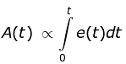Removing the sign of proportionality we have,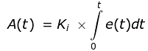Where, Ki is integral constant also known as controller gain. Integral controller is also known as reset controller.

#### Advantages of Integral Controller

Due to their unique ability they can return the controlled variable back to the exact set point following a disturbance that’s why these are known as reset controllers.

#### Disadvantages of Integral Controller

It tends to make the system unstable because it responds slowly towards the produced error.

### Derivative Controllers

We never use **derivative controllers** alone. It should be used in combinations with other modes of controllers because of its few disadvantages which are written below:

1. It never improves the steady state error.
2. It produces saturation effects and also amplifies the noise signals produced in the system.

Now, as the name suggests in a derivative controller the output (also called the actuating signal) is directly proportional to the derivative of the error signal. Now let us analyze derivative controller mathematically. As we know in a derivative controller output is directly proportional to the derivative of the error signal, writing this mathematically we have,https://www.electrical4u.com/equations/controlsystem/con-12-06-14-05.gifRemoving the sign of proportionality we have,https://www.electrical4u.com/equations/controlsystem/con-12-06-14-06.gifWhere, Kd is proportional constant also known as controller gain. Derivative controller is also known as rate controller.

#### Advantages of Derivative Controller

The major advantage of derivative controller is that it improves the transient response of the system.

### Proportional and Integral Controller

As the name suggests it is a combination of proportional and an integral controller the output (also called the actuating signal) is equal to the summation of proportional and integral of the error signal. Now let us analyze proportional and integral controller mathematically. As we know in a proportional and integral controller output is directly proportional to the summation of proportional of error and integration of the error signal, writing this mathematically we have,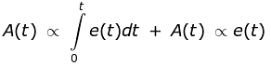Removing the sign of proportionality we have,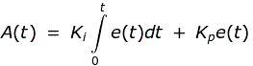Where, Ki and kp proportional constant and integral constant respectively.  
Advantages and disadvantages are the combinations of the advantages and disadvantages of proportional and integral controllers.

### Proportional and Derivative Controller

As the name suggests it is a combination of proportional and a derivative controller the output (also called the actuating signal) is equals to the summation of proportional and derivative of the error signal. Now let us analyze proportional and derivative controller mathematically. As we know in a proportional and derivative controller output is directly proportional to summation of proportional of error and differentiation of the error signal, writing this mathematically we have,https://www.electrical4u.com/equations/controlsystem/con-12-06-14-09.gifRemoving the sign of proportionality we have,https://www.electrical4u.com/equations/controlsystem/con-12-06-14-10.gifWhere, Kd and kp proportional constant and derivative constant respectively.  
Advantages and disadvantages are the combinations of advantages and disadvantages of proportional and derivative controllers